Table of Contents
1 Version history 1
1.1 document status 1
2 introduction 1

Version history
Version 2 Last saved 17. Dec. 2023 18:41 Wim Beaumont
Author W. Beaumont

document status
Internal use but can be shared
for discussion
none private or sensitive information

introduction

The Julabo FP51-SL can be controlled by a computer via the RS232 communication protocol.
The connector on the device is a sub D 9 female connector . BUT this is NOT compatible with the standard CTE connector ( a 1 : 1 female subD 9 to male subD 9 connector can be destructive !!)
A special cable has to be made .
Info about the cable that links to this document :
length ~ 40cm
cable Alpha wire 1176L
un-screened, 6 cores , 22AWG
hoods MHCCOV-9SC-LG (or CCOV-9SC-LG , 2360-0102-11 ,Farnell order code 3938013)

Function PC | To PC | To  chiller | Function  chiller | Wire color
 | Female sub D 9 | Male sub D 9
nc | 1 | 1 | nc | Not connected
RX | 2 | 3 | TX | red
TX | 3 | 2 | RX | green
nc | 4 | 4 | nc
GND | 5 | 5 | GND
nc | 6 | 6 | nc
RTS | 7 | 8 | CTS | blue
CTS | 8 | 7 | RTS | orange
nc | 9 | 9 | nc
nc |  |  | nc | white

additional info

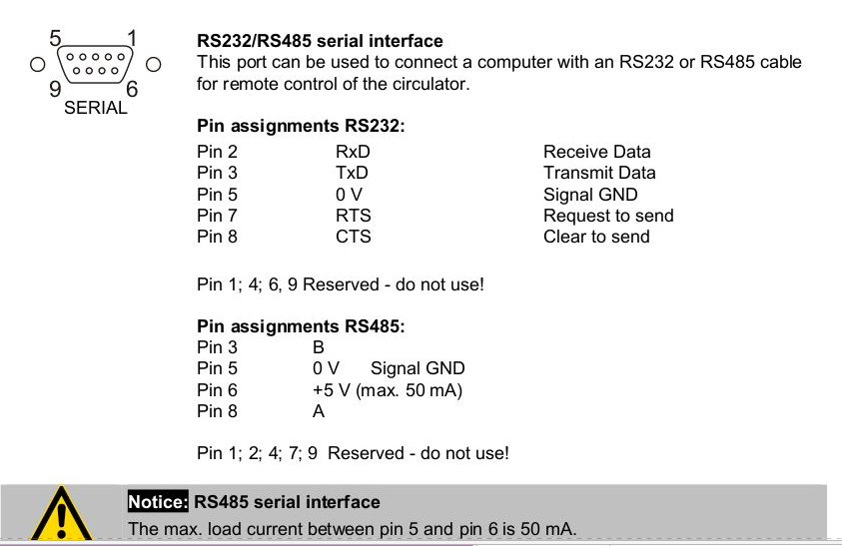Figure 1: information about the sub D 9 connector on the Julabo FP51-SL

